**Lamport’s Algorithm for Mutual Exclusion**

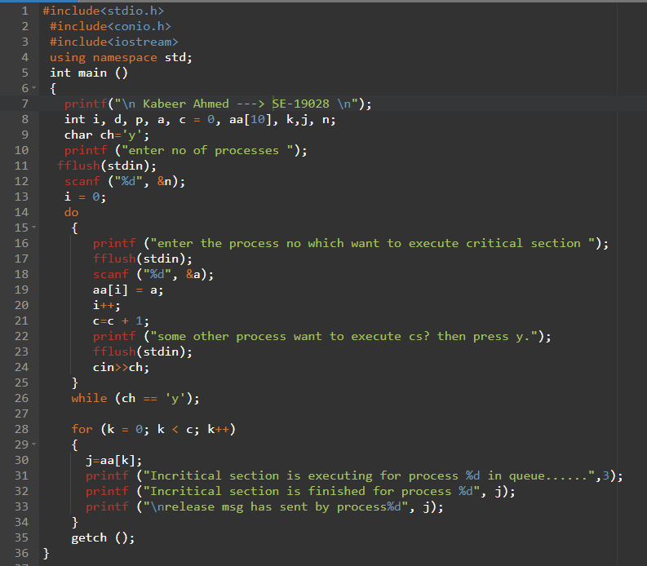

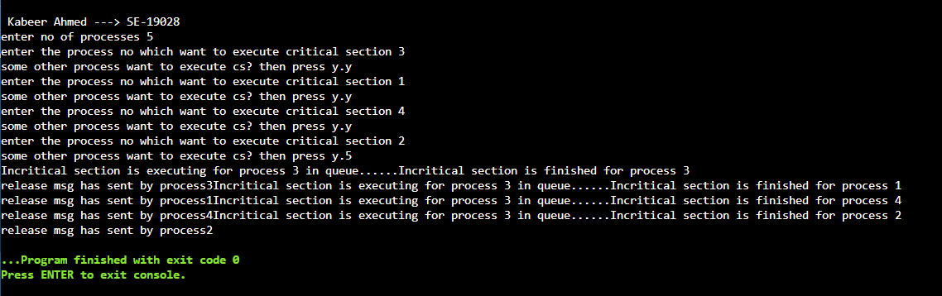

**Diagram made in Lamport’s Algorithm**

